Website Redesign for Therapy for Black Men Project Overview: Therapy for Black Men aims to redesign its website (https://therapyforblackmen.org/) to match the modern, clean, and engaging look and feel of the Novi Foundation site (https://novifoundation.avenuesols.com/). The goal is to create a user-friendly experience that enhances accessibility, engagement, and overall functionality while maintaining the organization’s mission and values. Please note that we would like to retain the look, feel, color, font, and layout of the <https://novifoundation.avenuesols.com/>

🔗 **Optimized Website Navigation**

📌 **Header Navigation Bar (Fixed at the Top)**

* **Home**
* **Find a Therapist**
* **Find a Coach**
* **About (Dropdown)** 
  1. **Join As A Therapist**

**○ Join As A Coach**

**○ Meet Our Team**

**○ Board Members**

**○ Terms of Use**

**○ Privacy Policy**

* **Resources (Dropdown)** 
  1. **Find a Therapist**

**○ Find a Coach**

**○ Blog**

**○ Contact Us**

* **Store *(New – Placed before the Donate button)***
* ❤ **Donate (Call-to-Action Button, Highlighted in Gold)**

📌 **Footer Navigation (Streamlined for Accessibility)**

* **© 2025 Therapy For Black Men - All Rights Reserved. Designed by Avenue Sol’s**
* 🌐 **Quick Links:** 
  1. **Find a Therapist | Find a Coach | Blog**

**○ About Us | Meet Our Team | Board Members**

**○ Therapist Sign Log In | Coaches Sign Log In**

**○ Terms of Use | Privacy Policy**

**○ Store**

**○ Donate (Highlighted for Visibility)**

**○ Contact Us ●** 📩 **Stay Connected:**

**○ Newsletter Signup**

**○ Social Media Icons (Instagram)**

🔹 **Design Enhancements for Usability**

* 📍 **Dropdown Menus: Organizing Resources and About into collapsible dropdowns makes the menu less cluttered.**
* 🎯 **Call-to-Action Emphasis: The Donate button should always stand out with a gold highlight to encourage contributions.**
* 📱 **Mobile-Friendly Hamburger Menu: Ensuring easy navigation for mobile users with collapsible categories**

# Home page Updates



[https://www.istockphoto.com/video/happy-healthy-athlete-appeciating-the-sun-while-on-a-run-gm469267 480-62361626](https://www.istockphoto.com/video/happy-healthy-athlete-appeciating-the-sun-while-on-a-run-gm469267480-62361626)

**Hero Section:**

* Use [**this video**](https://www.istockphoto.com/video/happy-healthy-athlete-appeciating-the-sun-while-on-a-run-gm469267480-62361626) as the background.
* **Main Headline:** "Supporting Black Men to Wholeness"
* **Subtext:** "Connect with a Therapist Today"
* **Call to Action:** "Get Support"

**Additional**

**Messaging:**



○ Capturing Automotive: Supporting Black Men to Wholeness ○ Beyond Media: THERAPY FOR BLACK MEN

○ Automotive and Corporate: Connect with a Therapist Today

○ **Logo Placement:** Ensure the Therapy for Black Men logo is prominently placed.

**Please leave the “A Message for You along with the image of the Black man on the left**

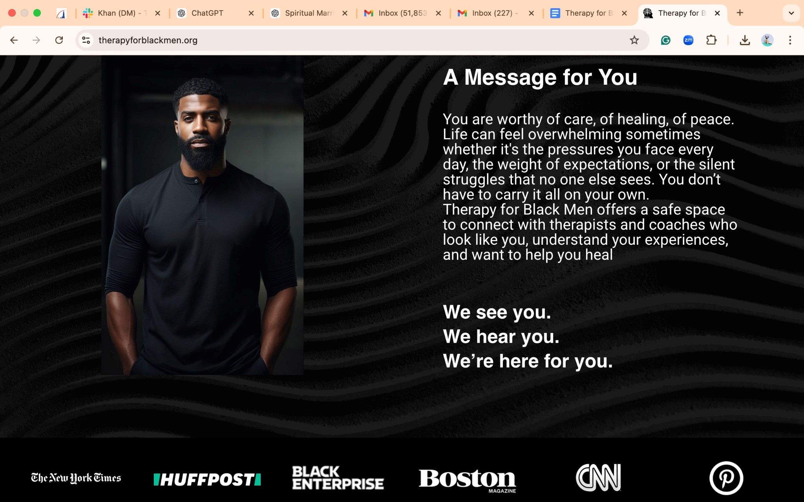

1. [**Image 1: “African American man feeling the light”**](https://www.gettyimages.com/detail/photo/african-american-man-feeling-the-light-royalty-free-image/523373188?adppopup=true)

This image evokes spiritual awakening and restoration. It would speak profoundly to visitors if placed above the quote:

**“We see you. We hear you. We’re here for you.”**

Place this image as a **full-width visual banner** under that statement, with subtle overlay text:

*"Even in brokenness, light reaches us. Healing is not far—it lives within the reach of grace."*

1. **Buttons:** Adds two buttons:

○ **Find a Therapist** links to the therapist directory.

○ **Find a Coach** link to the coach directory.



**Key Statistics here! LIVE Key Statistics Ticker for the Therapy for Black Men homepage. It features dynamically rotating statistics, smooth scrolling animations.**

## The Need for Therapy Access for Black Men and Boys

* 1 in 3 Black men who need mental health support will never receive it due to cost, stigma, and accessibility issues.
* 63% of Black men believe that discussing mental health is seen as a sign of weakness in their communities, preventing them from seeking help.
* Only 4% of U.S. therapists are Black, making culturally competent care difficult to find.
* Black men are 20% more likely to experience major depression than the general population but are significantly less likely to receive professional care.
* Suicide rates among Black youth have risen by 78% in the last two decades, making early intervention crucial.
* Culturally responsive therapy has been proven to increase engagement and success rates for Black men seeking help.

**This section will present these statistics in a visually engaging Live Ticker format to drive awareness and encourage action.**

**and high visibility placement with a call-to-action button like "Find a Therapist"**

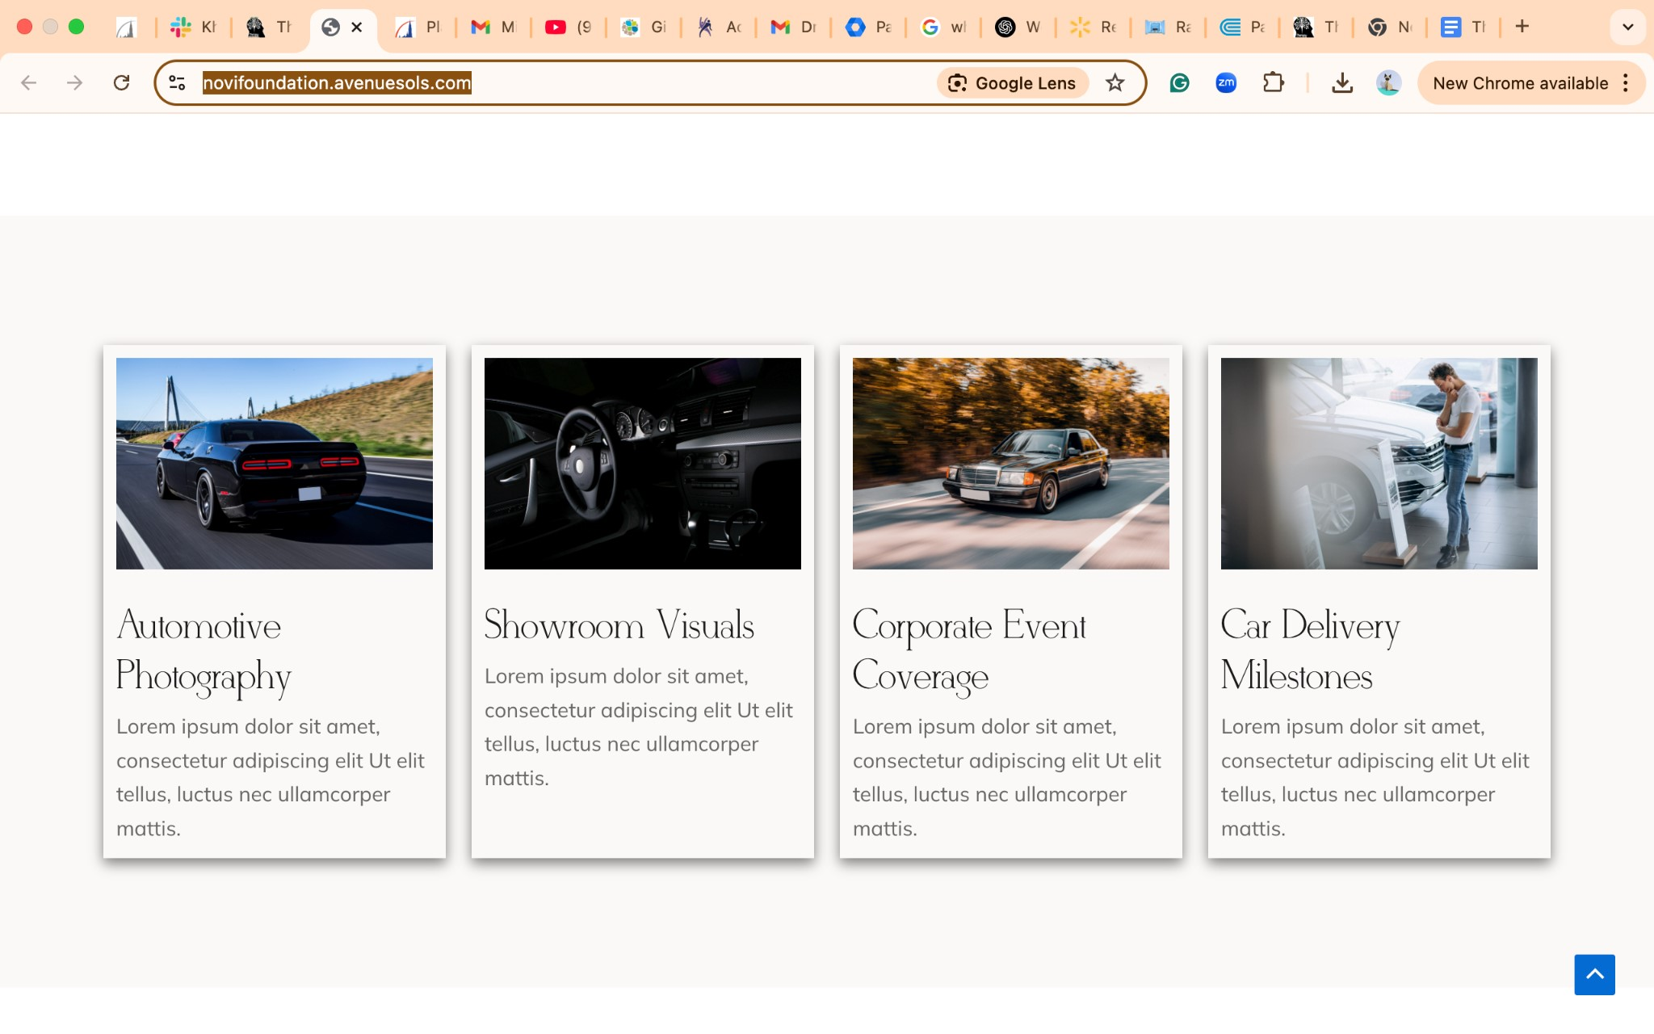

|  |
| --- |
| FIND A THERAPIST OR COACH |
| **Use our online directory to find the therapist or coach that fits your needs.** |
|  |
| APPLY FOR FREE HELP |
| **Apply for sponsored free therapy sessions, thanks to our donors.** |
|  |
| JOIN AS A THERAPIST OR COACH |
| **Increase your online presence by joining our online directory.** |
|  |
| SUPPORT OUR WORK |
| **Donate to Black Men & Boys without resources to engage in therapy.** |

|  |
| --- |
| **en & Boys without resources have therapy.** |
|  |

1. **Text Section:** “Begin Your Healing.”
2. **Buttons:** Adds two buttons:

○ **Find a Therapist** links to the therapist directory.

○ **Find a Coach** links to the coach directory.

[**Image 2: “Devout African American man praying”**](https://www.gettyimages.com/detail/photo/devout-african-or-african-american-man-prays-hands-royalty-free-image/1205467379?adppopup=true)

This powerful photo of reverence and surrender belongs in the **“A Safe Space, Always”** section. As the text affirms the sacred nature of the platform, this image would serve as a visual sanctuary—a reminder that healing begins where prayer and presence meet. Align this image to the left of the paragraph, paired with this overlay quote in soft italics: *"Here, you are not just heard—you are held. You are not just seen—you are known."*

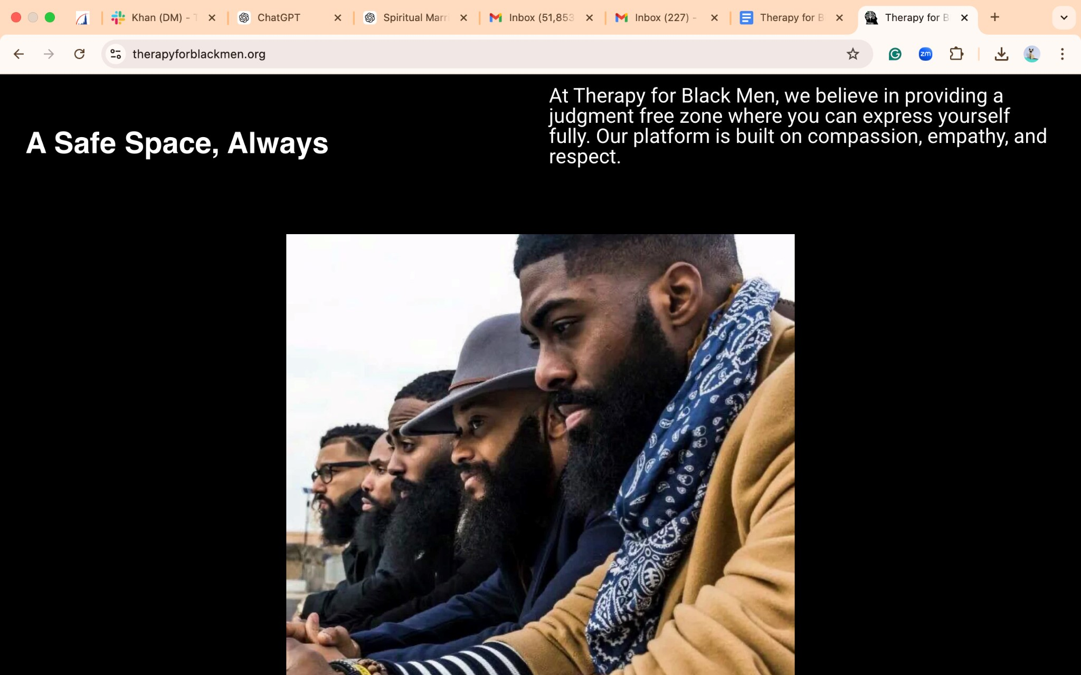

## A Safe Space, Always

At **Therapy for Black Men**, we are more than a platform—we are a sanctuary for your voice and your healing. Here, you will find a judgment-free zone where you can lay down your burdens and speak your heart without fear.

We are built on the principles of **compassion, empathy, honor, and respect**, ensuring that every interaction uplifts and empowers you. Your experiences, your pain, your triumphs—they all matter deeply to us.

# Support Options

**Are you seeking support for yourself or a loved one?**

**Find the Right Support for You or a Loved One**

* **Individual Therapy**: Personalized one-on-one care.
* **Couples Therapy**: Strengthen your bond through guided sessions.
* **Family Therapy**: Foster healthier communication and dynamics.
* **Child & Adolescent Support**: Specialized care for youth.
* **Group Therapy**: Heal together through shared experiences.
* **Faith-Based Therapy**: Spiritually centered support for those seeking a faith-driven approach.
* **Trauma-Informed Therapy**: Compassionate, trauma-sensitive care.
* **Coaching**: Guidance toward personal growth and success.

**The support options are hyperlinked to therapists and coaches specialties** Taking the first step toward healing can feel daunting, but you’re not alone. Let us walk with you.

## [ Take the first step toward wholeness today.]

**Featured Therapists**

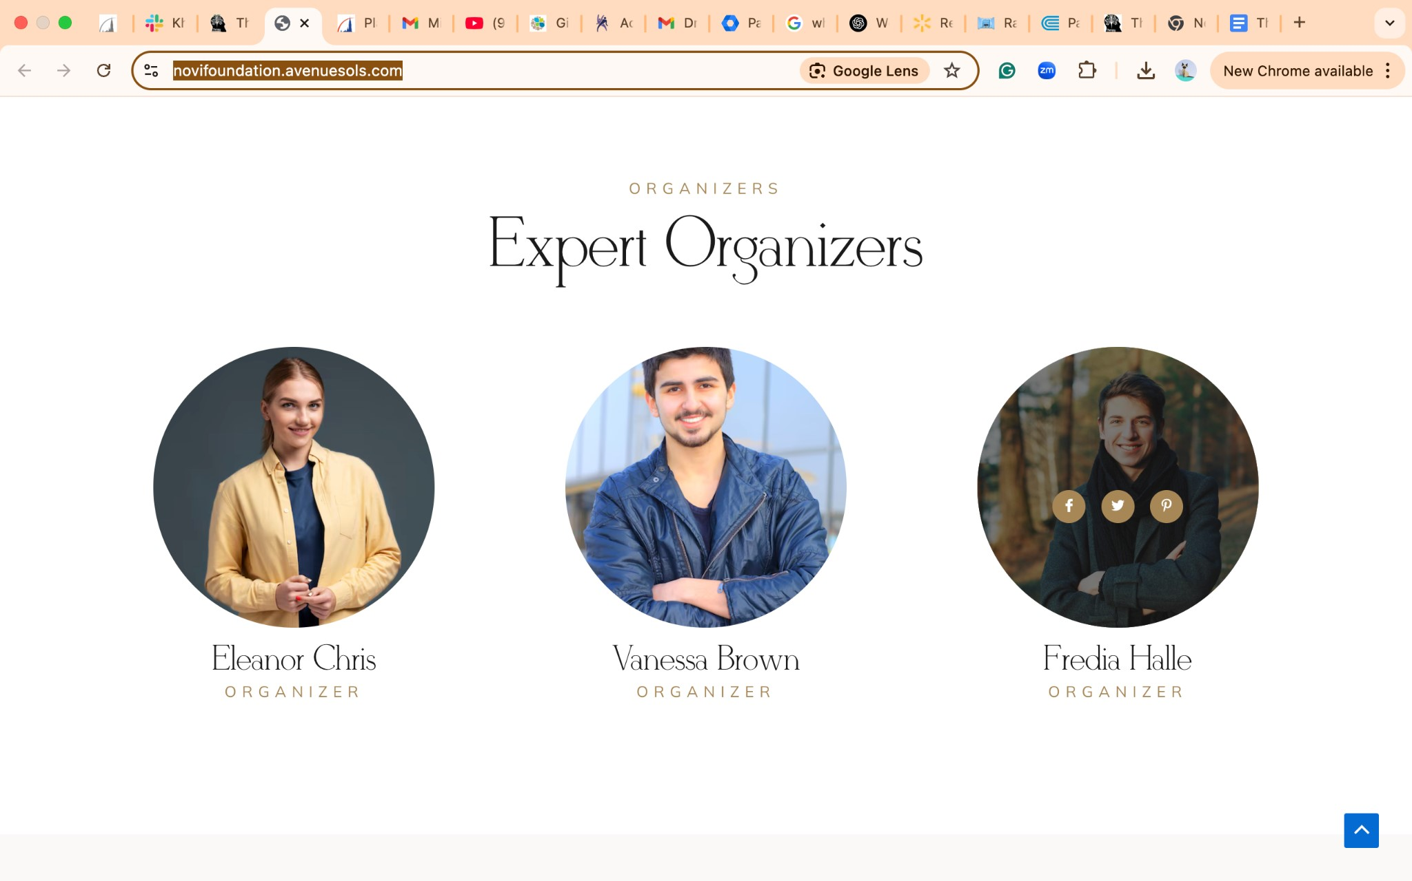

**Call to Action Button: Find a Therapist**

**Featured Coaches**



**Find a Coach**

### Testimonials & Success Stories

|  |
| --- |
| **● Rotating carousel showcasing real stories from Black men who found healing** |
| **through therapy.** |
| **● Quote sections emphasizing the power of culturally competent therapists.** |

**Strength Still Needs Support**

Even the strongest among us need a safe place to rest, to heal, and to grow. Strength doesn’t mean enduring alone—it means having the courage to seek support when you need it most.

At **Therapy for Black Men**, we provide a compassionate, judgment-free space with therapists who truly understand your experiences. Our mission is to walk with you on your journey to healing, offering the support you deserve to unlock your full potential.

**You don’t have to carry it all by yourself.**

**Take the first step today:**

🌐 [**therapyforblackmen.org**](http://www.therapyforblackmen.org/)

📞 **(646) 246-3064**

**Your healing starts here.**

|  |  |
| --- | --- |
|  | |
| **Find a Therapist Page** | |
| **Headline: : "Break the Silence. Embrace Healing. Find a Therapist Who** | |
| **Understands You"**  **Because Your Well-Being Deserves More** | |
| Finding the right support can feel overwhelming. You may be asking yourself: | |
| ● How close are they? |
| ● Will they accept my insurance? |
| ● Do they truly understand my experiences? |
| We understand how deeply personal this decision is, and at *Therapy for Black Men*, we’re | |
| committed to making it easier. | |
|  | |
|  | |
| **A Directory Designed With You in Mind** | |
| We’ve created a powerful, user-friendly tool to connect you with professionals who understand | |
| your journey. | |

|  |
| --- |
| ● Location: Find someone near you or explore virtual options for convenience and |
| flexibility. |
| ● Specialization: Whether you’re navigating anxiety, trauma, relationships, or |
| self-discovery, connect with therapists and coaches who have the expertise to guide you. |
| ● Credentials: Explore qualifications and experiences so you can feel confident in your |
| choice. |
| **Support Every Step of the Way**  Healing is a journey, not a destination, and you don’t have to walk it alone. Along with access to | |
| therapists and coaches, we provide resources and tools to support you as you work toward the | |
| peace, strength, and clarity you deserve. | |
|  | |
|  | |
| **You’re Not Alone** | |
| It’s time to let go of the message that you need to “man up.” Vulnerability is not weakness—it’s | |
| a courageous step toward a stronger, more fulfilled version of yourself. | |
|  | |
|  | |
| **Start Your Change Today** | |
| Take the first step. Let us help you find the therapist or coach who will stand by your side and | |
| help you align with your full potential. | |
| You don’t have to ‘man up’—start your healing journey today. | |
| **[ Find a Therapist ]** | |
|  | |
|  | |
| **Why Therapy Matters** | |
| ● Mental Health Support: Therapy provides the tools to manage anxiety, depression, and |
| stress. |
| ● Healing from Trauma: Process past experiences in a safe and supportive environment. |
| ● Relationship Building: Improve communication and strengthen connections. |
| ● Self-Discovery: Gain clarity, confidence, and resilience. |
|  | |
|  | |
| **How It Works** | |
| 1. Search for a Therapist: Use our advanced filters to find a therapist that matches your |
| needs. |
| 2. Browse Profiles: View therapist qualifications, specialties, and client reviews. |
| 3. Connect & Book a Session: Reach out directly to schedule an appointment or |
| consultation. |

|  |  |  |  |
| --- | --- | --- | --- |
|  | | | |
|  | | | |
| **Search Filters for Therapist Directory** | | | |
| ● Specialization: Anxiety, Depression, Trauma, Relationships, Personal Growth, Racial | | |
| Identity, Stress Management | | |
| ● Location: In-person or virtual therapy options | | |
| ● Insurance & Pricing: Filter by accepted insurance plans or self-pay options | | |
| ● Therapist Identity & Approach: Select by race, gender, faith-based approaches, and | | |
| therapeutic styles | | |
|  | | | |
|  | | | |
| **Featured Therapists Section** | | | |
| ● Grid layout displaying therapist profiles, including: | | |
|  | ○ | Profile picture |
| ○ | Name & credentials |
| ○ | Specialization |
| ○ | Location (Virtual/In-Person availability) |
| ○ | Pricing or insurance details |
| ○ | A brief bio/description |
| ○ | ‘View Profile’ button for booking or direct messaging |

|  |  |
| --- | --- |
|  | |
|  | |
| **Call-to-Action:** | |
| ● “Start Your Healing Journey Today” – Encouraging visitors to take the next step. |
| ● Prominently feature Find a Therapist buttons at the top and bottom of the page for easy |
| access. |
|  | |
|  | |
|  | |
|  | |
|  | |
|  | |
|  | |
|  | |
|  | |
| **Find a Coach Page** | |
| **Headline: "Find a Coach Who Truly Understands Your Journey"**  Introduction | |
| At ***Therapy for Black Men*,** we recognize that healing extends beyond therapy. Sometimes, | |
| what you need is guidance, structure, and accountability to achieve your personal and | |
| professional goals. Our directory of experienced life and executive coaches is designed to help | |
| Black men unlock their full potential and navigate life’s challenges with confidence. | |
| **Why Work with a Coach?** | |
| ● Personal Growth: Overcome obstacles and build self-discipline. |
| ● Career Development: Strengthen leadership skills and career advancement. |
| ● Relationship Coaching: Improve communication and strengthen relationships. |
| ● Health & Wellness Coaching: Develop habits for mental and physical well-being. |
| ● Financial Coaching: Learn how to manage finances and build wealth. |

**How It Works**

|  |
| --- |
| 1. Search for a Coach: Use our advanced directory filters to find a coach who specializes in |
| your area of need. |
| 2. Browse Profiles: View detailed coach profiles, including experience, specialties, and |
| client testimonials. |
| 3. Book a Session: Contact a coach directly to schedule a free consultation or coaching |
| session. |

**Search Filters for Coaches Directory**

|  |
| --- |
| ● Specialization: Personal Development, Career Growth, Relationships, Financial |
| Coaching, Health & Wellness |
| ● Location: In-person or virtual sessions available |
| ● Price & Packages: Various pricing options and coaching plans |
| ● Languages Spoken: Connect with a coach who understands your background and |
| culture |

**Featured Coaches Section**

● Display a grid layout of coach profiles, including:

|  |
| --- |
| ○ Profile picture |
| ○ Name & credentials |
| ○ Specialization |
| ○ Location (Virtual/In-Person availability) |
| ○ Pricing or insurance details |
| ○ A brief bio/description |
| ○ ‘View Profile’ button to book a session |

**Call-to-Action:**

|  |
| --- |
| ● “Start Your Coaching Journey Today” – Encouraging visitors to find a coach that fits their |
| needs. |
| ● Prominently feature Find a Coach buttons at the top and bottom of the page for |
| seamless navigation. |
|  | |
|  | |
|  | |
|  | |

■ Pricing or insurance details

■ A brief bio/description

■ A clickable button for booking or contact (e.g., View Profile).

1. **Mobile Optimization:** 
   1. Ensure the directory is fully optimized for mobile devices, with smooth navigation and easy-to-use filters.
2. **Call-to-Actions:** 
   1. Prominently feature Find a Therapist and Find a Coach buttons at the top and bottom of the page for seamless navigation.

|  |
| --- |
|  |
|  |

#### Join As a Therapist Page

Join Our Mission: Your Calling. Your Impact. Your Legacy.

Black men across the nation are in need of healing spaces—places where they can be heard, understood, and empowered. Too often, our brothers face barriers that prevent them from seeking the mental health support they deserve. You can be the difference.

At *Therapy for Black Men*, we are more than a directory. We are a movement dedicated to breaking stigmas, fostering resilience, and connecting Black men with therapists who truly understand them. When you join us, you are not just providing therapy—you are joining a collective effort to create a future where mental health care is accessible, empowering, and transformative.

Why Your Presence Matters

Mental health support for Black men is more critical than ever. The numbers speak for themselves:

* 1 in 3 Black men who need therapy will never receive it due to cost, stigma, or lack of access.
* Suicide rates among Black men and boys have skyrocketed in the last decade.
* Only 4% of U.S. therapists are Black, leaving our brothers struggling to find someone who understands their lived experiences.

By joining *Therapy for Black Men*, you help bridge the gap. You become a lifeline.

Why Join Us?

As a member of our network, you gain exclusive access to resources that elevate your reach and impact:

✅ A Personalized, Editable Profile – Highlight your expertise and let potential clients find you with ease.

✅ Direct Client Engagement – Connect directly with Black men seeking therapy, providing guidance where it’s needed most.

✅ Amplified Visibility – Get featured across our website, social media, and community networks, positioning yourself as a leader in mental health.

✅ Community & Networking – Join a thriving community of Black therapists, exchange knowledge, and contribute to transformational change.

Membership Details

💼 Individual Membership: $20/month

Join a growing network of professionals committed to empowering Black men through culturally competent therapy. Your membership includes:

* A customizable profile with direct client contact.
* Marketing support and visibility across our platform.
* Opportunities for professional development and networking.
* Contributions to articles, workshops, and community events that extend your impact beyond the therapy room.

Your Role in the Movement

Your compassion, expertise, and commitment could be the turning point for a Black man struggling in silence.

We don’t just want Black men to survive—we want them to thrive.

At *Therapy for Black Men*, we stand together to create a world where Black men are seen, valued, and supported.

Are You Ready to Make a Lasting Impact?

This is your time to step forward. Your voice, your presence, and your expertise matter.

Become a part of the solution. Join a legacy of change. Stand with us as we work to heal, uplift, and empower Black men everywhere.

[ Join Us Today ]

**Join As a Coach page**

**Empower. Inspire. Transform Lives.**

|  |  |  |  |  |  |  |
| --- | --- | --- | --- | --- | --- | --- |
| Black men and boys deserve guidance, encouragement, and actionable strategies to help them | | | | | | |
| thrive. Too often, they face barriers to success, mental well-being, and personal growth. You | | | | | |  |
| can be the coach who makes a difference. |  | | | | |
| At ***Therapy for Black Men***, we are building a movement—one that empowers Black men to | | | | |
| step into their full potential, cultivate resilience, and redefine success on their own terms. | | | |  |
| Whether they seek career coaching, life coaching, relationship coaching, or personal | | |  |
| development, your expertise can be the catalyst for lasting change. | |  |
|  | | | | | | | |
|  | | | | | | | |

**Why Your Role Matters**

|  |  |
| --- | --- |
| Coaching provides Black men with the tools, confidence, and mindset shifts they need to | |
| overcome challenges and build a future they are proud of. |  |

* 70% of Black professionals report feeling isolated in their careers due to lack of mentorship and guidance.
* Financial literacy and personal growth resources remain scarce in many Black communities.
* Mental health and success go hand in hand—when Black men have access to coaching, they are better equipped to thrive in all areas of life.

|  |  |
| --- | --- |
| By joining *Therapy for Black Men*, you become part of the solution. You become a guide, a | |
| mentor, and an agent of transformation. |  |
|  | | |
|  | | |

**Why Join Us?**

|  |  |  |  |  |  |  |  |
| --- | --- | --- | --- | --- | --- | --- | --- |
| As a coach in our network, you’ll gain exclusive access to tools that expand your reach and | | | | | | | |
| impact: |  | | | | | | |
| ✅ A Personalized, Editable Profile – Showcase your coaching philosophy, specializations, and | | | | | | | | | |
| expertise to connect with potential clients. | |  | | | | | | | |
| ✅ Direct Client Engagement – Get discovered by Black men actively seeking guidance, | | | | | |
| mentorship, and personal development strategies. | | | | |  |
| ✅ Increased Visibility – Feature your coaching services on our website, social media, and | | | | | | |
| marketing campaigns, amplifying your influence. | | |  | | | |
| ✅ Exclusive Community & Networking – Join a powerful network of Black coaches, therapists, | | | | | | | | |
| and leaders dedicated to empowering Black men. | | | |  | | | | |
|  | | | | | | | | | | |
|  | | | | | | | | | | |

**Who Can Join?**

|  |  |
| --- | --- |
| We welcome certified coaches, life strategists, executive coaches, and wellness coaches who | |
| are passionate about supporting Black men. Whether you specialize in: |  |

* Career & Leadership Coaching
* Financial Literacy & Wealth Building
* Health & Wellness Coaching
* Relationship & Family Coaching ● Personal Development & Mindset Shifts

…there is a place for you here.

|  |
| --- |
|  |
|  |

**Membership Details**

💼 Join for Just $20/Month

As a member, you’ll receive:

* A customizable profile that allows potential clients to find and book you.
* Access to marketing support, social media promotion, and community events.
* Opportunities to contribute workshops, articles, and coaching programs that support Black men’s growth.

|  |
| --- |
|  |
|  |

**Your Impact Starts Here**

|  |  |  |  |
| --- | --- | --- | --- |
| Every coaching session you lead is an opportunity to ignite change, inspire growth, and create | | | |
| breakthroughs. |  | | |
| Black men need mentors who understand their experiences, challenges, and potential. Your | | |
| guidance could be the difference between doubt and confidence, stagnation and success. | |  |
|  | | | | |
|  | | | | |

**Are You Ready to Make a Lasting Impact?**

This is your time to step up and be the coach who transforms lives.

|  |  |
| --- | --- |
| Join a movement that is shaping the future of Black men. Become a coach with Therapy for | |
| Black Men today. |  |

**[ Join Us Today ]**

**Meet our Team PAGE**

**\*\*\*Please remove yellow highlights around the photos.**

**Welcome KINGS!**

At ***Therapy for Black Men,*** we honor your strength, your resilience, and your worth.

This space was born from a de56ep understanding of the unique challenges and stigmatization that Black men and boys face every day. We recognize the weight you carry—the unspoken struggles, the expectations, and the pressure to always be strong.

But here, strength looks different. Strength is seeking help. Strength is healing. Strength is reclaiming your mental and emotional well-being.

Our mission is clear: to break down the walls of stigma that have held too many back for too long. We’ve created a dedicated space where Black men can feel seen, heard, and supported—a space where accessing mental health resources is not a challenge but a powerful step forward.

Through our comprehensive database of culturally competent professionals and targeted resources designed for you, we’re making it easier than ever for you to find the help you need and deserve. Because you are worthy of support. You are worthy of care. You are worthy of healing.

This is your space. This is your moment. Welcome to a community built for you, where you can lay your burdens down and rise as the king you are meant to be.

Let’s begin the journey—together.

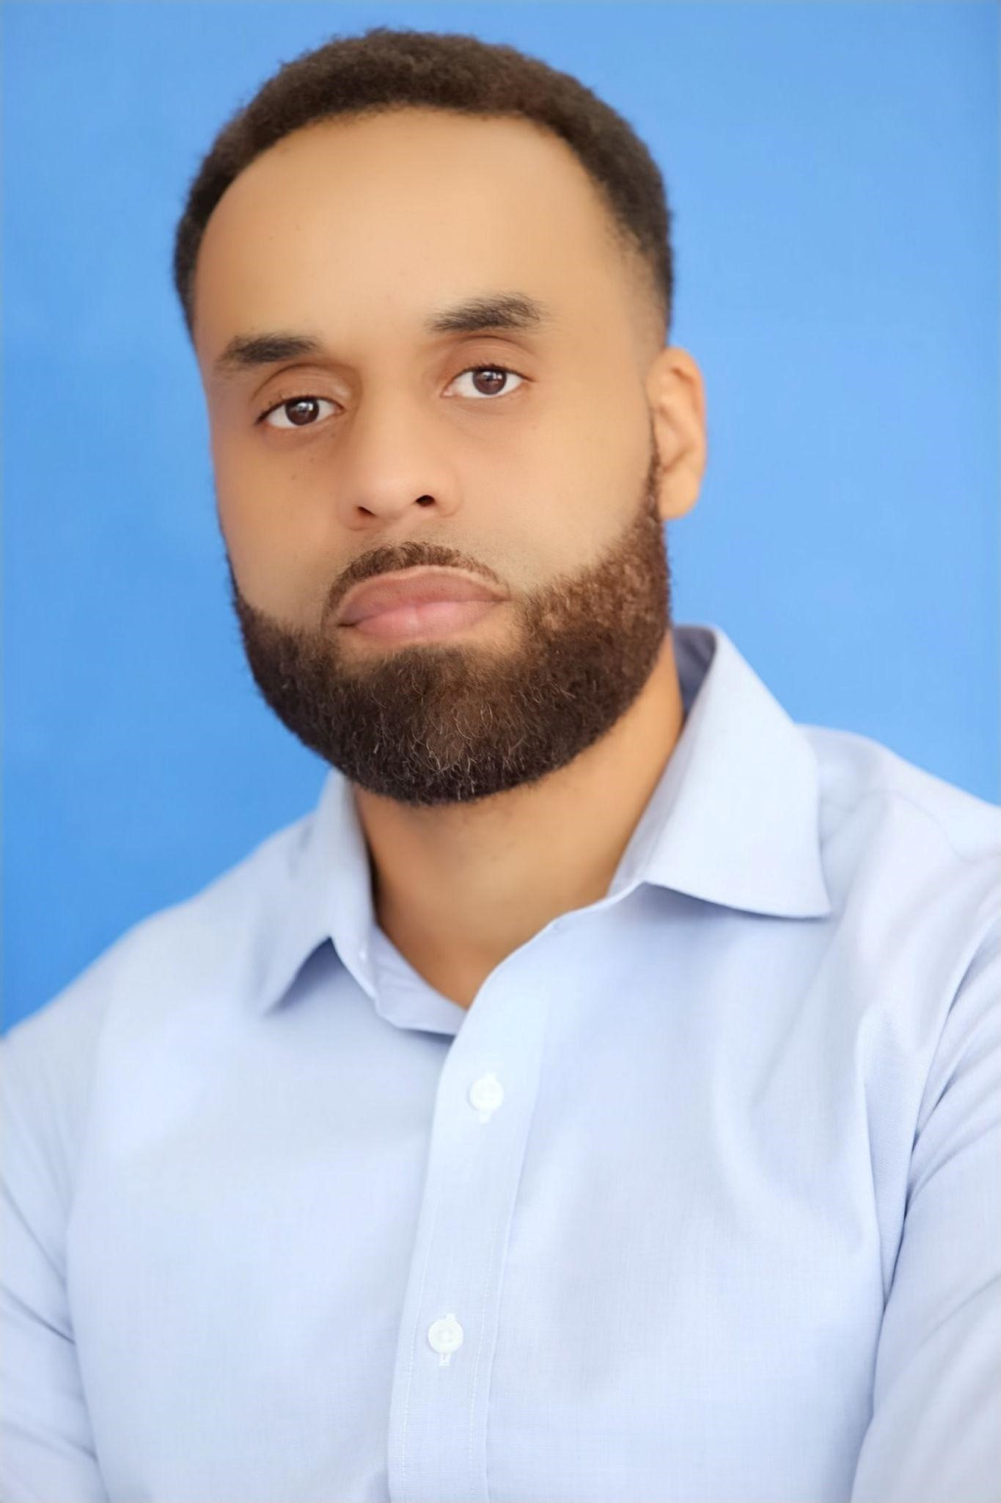

**Benjamin Calixte: Founder of Therapy for Black Men**

**"Our team is committed to helping improve our men's overall well-being and mental health as well as preventing the suffering that occurs when wounds are unaddressed. Our boys and men deserve better."** —*Benjamin Calixte*

##### The Journey of Impact

My greatest joy in life was being a stay-at-home dad. That role, rooted in love and service, taught me the profound importance of presence, connection, and intentional impact. It shaped my understanding of what it truly means to nurture potential and inspired me to extend that care beyond my own family.

My father instilled in my brothers and me a passion for sports—a foundation that introduced me to discipline, resilience, and teamwork. Whether it was basketball, football, baseball, or track, these experiences fueled my growth and became a cornerstone of my identity. Coaching naturally followed, allowing me to guide others toward their best selves.

Through fatherhood and coaching, I witnessed firsthand the transformative power of genuine support in shaping mental and emotional well-being. This realization became my calling: to create a space where Black men could find the care and guidance they need to thrive. Together with my wife, Vladimire, we built TherapyForBlackMen.org—a platform to educate, inspire, and empower Black men every single day.

##### Championing Mental Wellness for Black Men

As a certified professional coach and New York University-trained life and executive coach, I approach health and wellness holistically. My professional journey includes 17 years in customer relations and 8 years in managerial roles, blending hands-on experience with a deep commitment to advocacy and empowerment.

With a Bachelor of Science degree in Psychology from Brooklyn College, I have spent my career equipping individuals with the tools to achieve personal and professional growth. Through Therapy for Black Men, I am driven to eliminate barriers that prevent Black men from accessing mental health resources.

Our directory provides free therapy sessions with qualified professionals and connects men to culturally resonant support. By bridging the gap between need and access, we strive to ensure that Black men and boys have the resources they deserve.

##### A Voice for Change

In addition to our direct services, I am deeply committed to raising awareness of the systemic issues affecting Black men. From unconscious bias and inclusion to the empathy gap and societal perceptions, I speak at organizations such as Walmart and the Congressional Black Caucus to address these challenges and foster change.

I also serve as a Couples Coach, focusing on holistic approaches to relationships and guiding individuals toward deeper connections.

##### A Life Rooted in Love and Purpose

When I’m not coaching or advocating, you’ll often find me reading, writing, or coaching my children in track and field. I’m proud to have been married to my incredible wife, Vladimire, for 20 years, and together we’ve built a family centered on love and growth.

##### Why This Work Matters

Our mission is simple but vital: to improve the mental health and overall well-being of Black men and boys, breaking the cycles of unaddressed wounds and generational pain. We are here to say that Black men deserve better—because healing isn’t just an option, it’s a right.

For inquiries or support:

##### ✉ BenjaminCalixte@therapyforblackmen.org

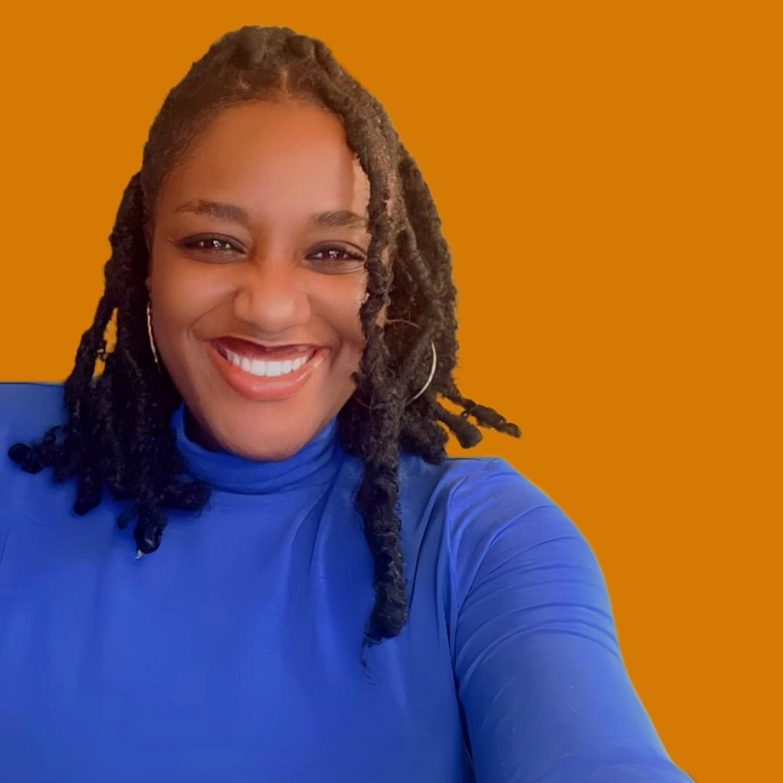

##### Vladimire Calixte: Founder of Therapy for Black Men

**"Your healing matters because healing is a destiny decision."**

— *Vladimire Calixte*

As a child growing up without a father in the household, I felt the weight of an immeasurable void. Watching other children interact with their fathers was a painful reminder of the connection I yearned for but never had. That early loss shaped me profoundly, instilling a deep understanding of how unhealed wounds can affect every aspect of our lives.

Through my own personal struggles and two decades as a therapist, I’ve come to see a universal truth: we’ve all carried the scars of trauma in some form. Yet, for Black men, the weight of societal expectations often multiplies that pain. From the time they are boys, Black men are told to “be strong,” “walk it off,” “don’t cry,” and “man up.” These harmful messages discourage vulnerability and perpetuate silent suffering.

I’m here to tell you: **you’re not meant to go on your journey alone.**

**Why I Founded TherapyForBlackMen.org**

As a mother and wife, I witness the immeasurable power of a loving father and husband in shaping a family. I see my husband, Benjamin, pouring his strength and care into our children every single day. His presence shows me just how transformational healing and love can be.

As a therapist, I have the privilege of witnessing the courage Black men bring into the therapy space. Each story they share is an act of bravery, a defiance of the harmful stereotypes that seek to silence them. I started TherapyForBlackMen.org to create a sanctuary—a place where men of color could access the tools, support, and community needed to reclaim their strength and rewrite their narratives.

**About Vladimire Calixte**

I am proud to bring both lived experience and professional expertise to this mission. Over the last 20 years, I’ve worked with individuals, couples, and families from all walks of life—including celebrities, politicians, and professional athletes—helping them overcome addiction, depression, anxiety, trauma, and more.

* **Awards**: Multiple recognitions for my work in mental health, relationships, and personal empowerment.
* **Education**: Bachelor’s degree in Sociology from Hunter College; Master’s degree in Applied Psychology from New York University.

Beyond my professional work, I find joy in the simple and meaningful moments: writing, singing, cooking, dancing, and, most importantly, spending time with my family. I am a proud wife of 20 years and mother to two incredible children who remind me every day of the importance of love and healing.

**My Commitment to You**

Through TherapyForBlackMen.org, my mission is clear: to ensure that no Black man has to navigate his healing journey alone. Together, we can challenge the myths, break the stigmas, and embrace the truth—**that strength is found in vulnerability, and healing is your birthright.**

For inquiries or support:

✉ **VladimireCalixte@therapyforblackmen.org**

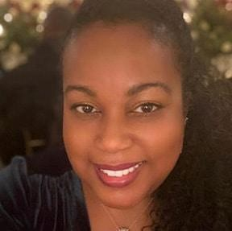

Sacheen Sawney: Virtual Care Executive Manager

**"Healing is a collective effort. Together, we can create a world where Black men feel seen, supported, and empowered to thrive."** —*Sacheen Sawney*

Sacheen Sawney is a visionary leader and compassionate advocate whose life's work is centered on uplifting communities and fostering wellness. As the Virtual Care Executive Manager at Therapy for Black Men, she brings a wealth of experience in event production, community engagement, and mental health advocacy to empower Black men on their healing journeys.

Sacheen’s professional path reflects her unwavering commitment to wellness and education. From her impactful tenure at the American Museum of Natural History to her creative leadership at Mentoring Up, she has consistently championed initiatives that create meaningful change. Her work is deeply rooted in her Caribbean heritage, which fuels her passion for helping men of color align with their greatness and achieve lasting well-being.

In 2021, Sacheen joined Spiked Spin Wellness Co. as General Manager, where she furthered their mission of fostering generational health in communities of color. This role was a natural extension of her dedication to addressing disparities and cultivating spaces for growth and healing. Now, at Therapy for Black Men, Sacheen is focused on breaking the stigma surrounding mental health and ensuring that Black men have access to the care they deserve.

Sacheen holds a B.A. in Psychology from Brooklyn College, equipping her with the academic foundation and emotional insight to bridge the gap between the community and the transformative power of therapy. Her work is not just a career—it is a calling to guide men of color toward a life of wholeness, strength, and self-discovery.

**For inquiries or support:**

✉ **SacheenSawney@therapyforblackmen.org**

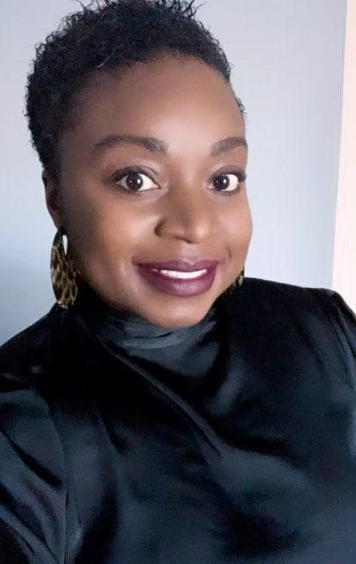

##### Sabrina Lamour: Celebrity Photographer for Therapy for Black Men

"Through the lens, I don’t just capture moments—I uncover stories, emotions, and the essence of who we are."

— *Sabrina Lamour*

A Vision Beyond Borders

Dubbed "Natural Eye," Sabrina Lamour is a worldwide photographer known for her organic, relatable, and deeply personal approach to every shoot. Born in Haiti and raised in the vibrant tapestry of New York City, Sabrina’s grassroots remain in the heart of NYC, but her vision transcends borders, bringing global narratives to life.

With her camera as her voice, Sabrina has traveled across the United States and ventured to Israel, Palestine, Africa, Turkey, Canada, France, and London on photographic missions that capture not just images but the soul of her subjects. Her works have graced the pages of Vogue magazine, while her portfolio boasts collaborations with prominent events and organizations, including:

* NY Fashion Week
* Super Bowl XLIV in Miami
* Pioneer Girls Conference
* RGE Foundation Annual Conference
* MLK Now
* Afro B. Album Release
* A Night with Chrisette Michele
* And many more red-carpet events, fashion shows, and charity initiatives.

A Blend of Art and Advocacy

Sabrina’s work is more than just photography—it’s a reflection of her passion for human connection and storytelling. Her artistry bridges cultures, celebrates diversity, and amplifies voices that often go unheard. Whether she’s behind the scenes of a high-profile event or on a mission to document everyday resilience, Sabrina brings authenticity, care, and a profound respect for her craft and her subjects.

Grounded in Service

Sabrina’s dedication to community is deeply rooted in her academic and personal journey. A graduate of SUNY Empire State College with a B.S. in Human & Community Services, Sabrina combines her artistic vision with a heart for service. Her role with Therapy for Black Men aligns perfectly with her mission to use her gifts to uplift, inspire, and empower.

The Power of the Lens

Through her photography, Sabrina continues to redefine what it means to see, to understand, and to connect. As the Celebrity Photographer for Therapy for Black Men, she captures the essence of the movement—men standing in their truth, breaking barriers, and embracing healing.

For inquiries or collaborations:

✉ SabrinaLamour@therapyforblackmen.org

***Supporting Black Men to Wholeness!***

**Board Members Page**

***Welcome Kings!***

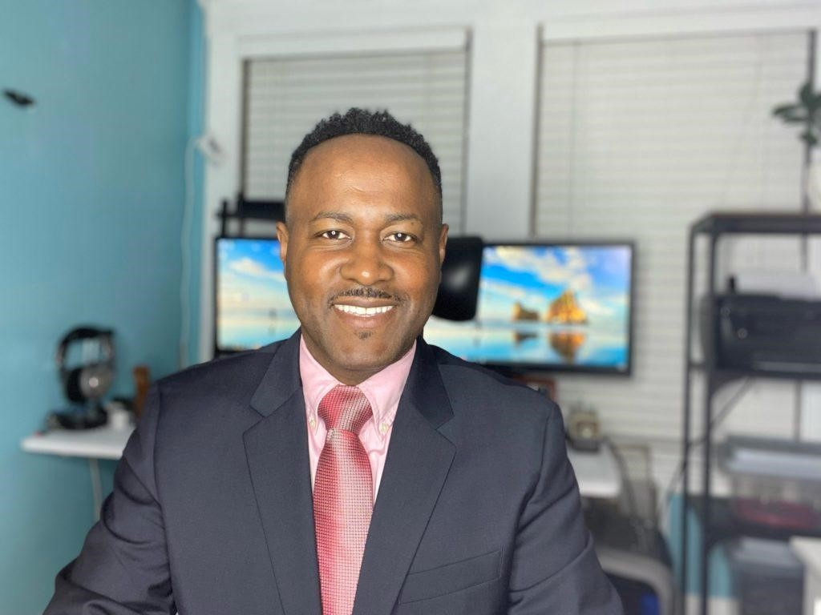

**Georges Louis-Jeune: Board Member**

Georges Louis-Jeune is a devoted leader, compassionate advocate, and a champion of creating meaningful impact for individuals and families. As the Information Systems Manager for CVS Corporation, Georges balances his professional expertise with a deeply personal mission: to empower others to live with purpose, joy, and resilience.

A native of Brooklyn, NY, Georges carries the values of community, accountability, and leadership into every aspect of his life. With a bachelor’s degree in Business and a focus on leadership from Northeastern University, he has cultivated a career grounded in

problem-solving and forward-thinking strategies. But for Georges, leadership extends beyond the workplace—it’s about listening, uplifting, and building a strong foundation for others to thrive.

For over 23 years, Georges has shared his life with his wife, building a family rooted in love and support in their Massachusetts home with their two children. His belief in the power of a strong support system fuels his passion for giving back. He thrives on being involved in processes that not only transform lives but also strengthen families and communities.

Georges holds fast to the idea that having the right tools—whether for a project, a personal challenge, or a dream—makes success possible. Yet he also recognizes the power of human connection, believing that sometimes all it takes to change a life is a listening ear.

**Why Therapy for Black Men Matters**

For Georges, Therapy for Black Men represents more than a platform—it’s a movement to dismantle barriers, foster healing, and empower Black men to reclaim their mental health and well-being. He understands that accountability, leadership, and support are key ingredients in personal transformation, and he is committed to helping the organization expand its reach and impact.

**"When we empower Black men to heal and lead, we transform families, communities, and the future. It all begins with connection and the courage to listen."** — *Georges Louis-Jeune*

For inquiries or support:

✉ **GeorgesLouisJeune@therapyforblackmen.org**

***Steven***

***Pascal:***

***Board***

***Member***

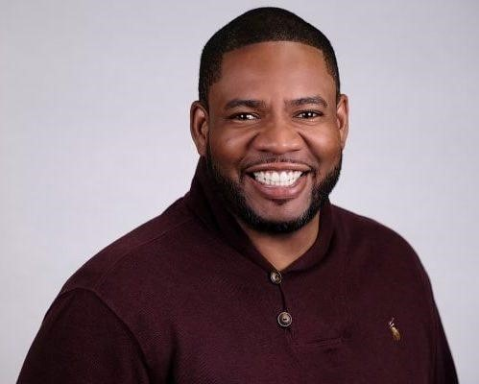

Steven Pascal is a dedicated advocate for vulnerable populations, bringing 25 years of transformative experience in human services to Therapy for Black Men. His career spans critical areas such as juvenile justice, workforce development, specialized foster care, and both elementary and higher education. Throughout his journey, Steven has remained steadfast in his mission to uplift communities and create pathways for healing and opportunity.

Currently, Steven serves as the Director of Home Visiting at the Children’s Trust of

Massachusetts, where he oversees 24 programs supporting young, first-time parents. Through his leadership, these programs provide critical resources and compassionate care to families navigating some of life’s most challenging moments. Steven’s expertise extends to facilitating impactful trainings and workshops, often sharing his knowledge at state and national conferences dedicated to serving vulnerable communities.

Steven’s certification in the Strengthening Families Protective Factors framework, awarded by the Alliance of Children’s Trust Funds, underscores his commitment to equipping families with the tools to thrive. His work is a testament to the belief that strengthening individuals strengthens entire communities.

A proud native of Brooklyn, NY, Steven holds a Bachelor of Political Science from Salem State University and a Master of Urban Affairs from Boston University. As a devoted husband and father, he understands the importance of family and uses his personal and professional insights to guide his advocacy for Black men and boys.

Steven’s involvement with Therapy for Black Men reflects his dedication to creating spaces where Black men can access the support they need to heal, grow, and realize their full potential.

“***When we invest in the well-being of men, we invest in the future of families, communities, and generations."*** — Steven Pascal

***For inquiries or support:***

✉ ***StevenPascal@therapyforblackmen.org***

*Strength still needs support!*

**Donate page**

**Support Our Mission: Change Lives Through Mental Health Access**

**At Therapy for Black Men, we’ve witnessed the transformative power of mental health support when barriers are removed. Thanks to the incredible generosity of our donors, we’ve been able to provide over $150,000 to fund free therapy sessions for Black men and boys across the nation. Together, we are changing lives and breaking the cycles of silent suffering.**

**Why Your Support Matters**

**A core part of our mission is to make therapy not just accessible—but empowering—for Black men and boys. Many in our community face financial obstacles that prevent them from seeking the care they need. Your donation directly changes that.**

**By contributing to Therapy for Black Men, you’ll help sponsor ten free therapy sessions for a man or boy who deserves healing without the weight of financial burden. Your gift isn’t just a contribution—it’s a lifeline that offers hope, healing, and a chance for a brighter future.**

**Make an Immediate Impact**

**With an online donation, your generosity begins working right away. Every dollar you give ensures that Black men and boys receive the professional mental health care they deserve. Together, we can continue to make therapy accessible, one session at a time.**

**Link to Donobox Organization Account**

**Your support is more than a gift—it’s a commitment to the well-being of our community.**

**Thank you for standing with us.**

***Please note: Donations are not tax-deductible.***

**Contact Us Page:**

**We're Here for You**

At **Therapy for Black Men**, our mission goes beyond providing resources—we’re dedicated to creating a community where you feel truly seen, supported, and empowered. Whether you’re reaching out with a question, seeking assistance, or exploring a partnership, we want you to know: **you matter to us.**

##### General Inquiries

Have a question that’s not addressed on our site?

Looking for us to tackle a specific topic on our Instagram page?

We’d love to hear your thoughts, ideas, and feedback!

##### 📧 info@therapyforblackmen.org

##### Tech Support

If you’re a therapist listed in our directory and need help managing your profile or resolving technical issues, our team is here to assist you.

##### 📧 support@therapyforblackmen.org

##### Booking

Looking to invite one of our inspiring leaders to speak or participate in your event? Our incredible team is available for engagements that inspire, educate, and empower:

##### ● Benjamin Calixte ● Vladimire Calixte ● Sacheen Sawney ● Sabrina Lamour ● Davian Chester ● Georges Louis-Jeune (Board Member)

● **Steven Pascal** (Board Member)

Send your event details to the respective email address, and let us handle the rest.

##### Your Voice Matters

Whether you’re reaching out with a simple question or the start of a transformative collaboration, we’re ready to listen. Together, we’re building a future where healing, connection, and empowerment thrive for Black men everywhere.

##### [Subscribe to Our Emails]

Don’t miss updates, resources, and inspiration—join our mailing list today!

**We’re here for you. Always.**

Here are some key features I would like to implement for the **Therapist & Coach Dashboard** on the website:

1. **Profile Management**

**Editable Bio & Credentials** – Therapists and coaches can update their professional bio, education, specialties, and experience.

**Profile Picture Upload** – Ability to upload and change their profile picture.

**Service Offerings** – Specify services they provide, including pricing, session length, and availability.

1. **Appointment Scheduling**

**Availability Calendar** – Set and update available time slots.

1. **Communication Tools**

**Secure Messaging** – A built-in messaging system to communicate with potential and existing clients.

**Notifications** – Alerts for new messages, appointment requests, and profile updates.

1. **Analytics & Insights**

**Profile Views & Engagement** – See how many people visit their profile.

**Client Retention Stats** – Track recurring clients and session trends.

**Session Trends** – Identify peak times and popular services.

Also, I would like the therapists and coaches to be manually approved before their profiles go live. This ensures quality control, verification of credentials, and alignment with the mission of Therapy for Black Men. Here's how we can structure the approval process:

**Therapist Profile Approval Workflow:**

* + **Therapist/Coach Signs Up** – Creates an account and submits their profile details.
  + **Uploads Required Documents** – Licenses, certifications, ID verification (if needed).
  + **Admin Review & Verification** – An admin (or designated reviewer) checks credentials and profile details.
  + **Approval or Revisions** – If everything is correct, the profile is approved and goes live. If revisions are needed, the therapist gets feedback.
  + **Profile Goes Live** – Once approved, they can start accepting clients.

**Optional Features for Approval Process:**

**Automated License Verification** (if we integrate with a verification database).

**Status Notifications** – Therapists get email updates about their approval status.

**Admin Dashboard for Approvals** – A separate panel where admins can review and approve/reject applications.

I would also like to add a **"Verified by Therapy for Black Men"** seal to add credibility and trust for potential clients.

**How It Would Work:**

* **Profiles Go Live Immediately After Approval** – Once an admin reviews and approves a therapist or coach, their profile becomes publicly visible.
* **Automatic Verification Seal** – Upon approval, the system will automatically display the **"Verified by Therapy for Black Men"** seal under their profile photo.

a digital badge with a checkmark: Color scheme to align with Therapy for Black Men's branding.

(edited)

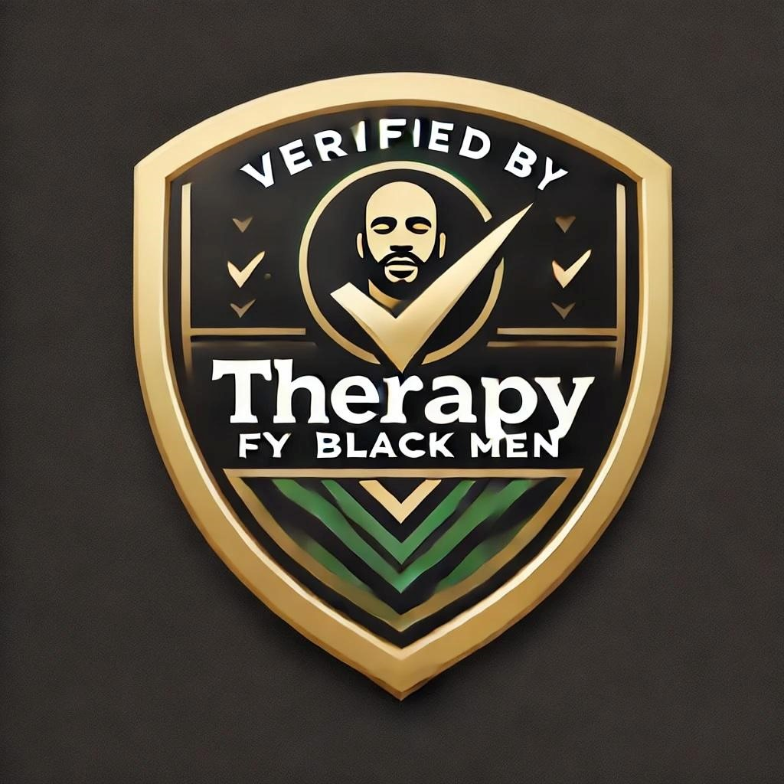

Another addition, please!

A **live ticker** on the homepage showcasing the **$150,000 in free therapy provided** will highlight Therapy for Black Men's impact and encourage more support from donors, therapists, and the community.

* **Ticker Style:**

* **Placement on Homepage:**

**Top right-hand corner** ● **Text Example for the Ticker:**

**"Together, we’ve provided $150,000 in free therapy for Black men & boys in need. Thank you for making healing possible!"**

#### 🌿 Apply for Free Therapy Help Page

*We see you. We hear you. We're here for you. Therapy for Black Men is committed to ensuring that financial barriers don’t prevent you from getting the support you deserve. Please take a moment to answer a few questions so we can connect you with the right therapist.*

1. **Basic Information** 
   * **Full Name:** *(First & Last Name)*
   * **Email Address:** *(For confidential updates about your application)* ● **Phone Number (Optional):** *(For scheduling assistance, if needed)* ● **Preferred Contact Method:**

○ ⬜ Email

○ ⬜ Phone

○ ⬜ Text

1. **Age Group** 
   * ⬜ Under 18 *(If under 18, parent/guardian consent will be required.)*
   * ⬜ 18-24
   * ⬜ 25-34
   * ⬜ 35-44
   * ⬜ 45-54
   * ⬜ 55+
2. **How Would You Like to Receive Therapy?** 
   * ⬜ **Virtual (Online Sessions)**
   * ⬜ **In-Person** *(If available in your area)*
   * ⬜ **No Preference**
3. **What Brings You to Therapy? *(Select all that apply)*** 
   * ⬜ Anxiety or Stress
   * ⬜ Depression or Mood Concerns
   * ⬜ Relationship Challenges
   * ⬜ Family Issues
   * ⬜ Grief & Loss
   * ⬜ Trauma or PTSD
   * ⬜ Racial Identity & Cultural Issues ● ⬜ Personal Growth & Self-Esteem
   * ⬜ Career or Life Transitions
   * ⬜ Other (Please describe briefly) _______________
4. **Have You Ever Attended Therapy Before?** 
   * ⬜ Yes
   * ⬜ No
5. **What Type of Therapist Would You Feel Most Comfortable With? *(Check any that apply, or leave blank if no preference.)*** 
   * ⬜ Male Therapist
   * ⬜ Female Therapist
   * ⬜ No Preference
6. **Financial Need Confirmation**

*Our free therapy sessions are reserved for those facing financial barriers. Please confirm your current situation:*

* + ⬜ I am experiencing financial hardship and cannot afford therapy at this time.

1. **Anything Else You’d Like Us to Know? *(Optional)***

***(Open text box for additional details)***

1. **Agreement & Consent**

⬜ *I understand that free therapy sessions are subject to availability, and I will be matched based on the best available therapist for my needs.*

⬜ *I agree to be contacted by Therapy for Black Men regarding my application and therapy options.*

🖤 **You are not alone. We are here for you. Once you submit your application, our team will carefully review it and follow up with you as soon as possible. Thank you for taking this step toward healing.**

**[Submit Application]** *(Button)*

|  |
| --- |
|  |
|  |

#### 🛍 STORE LANDING PAGE COPY (Draft)

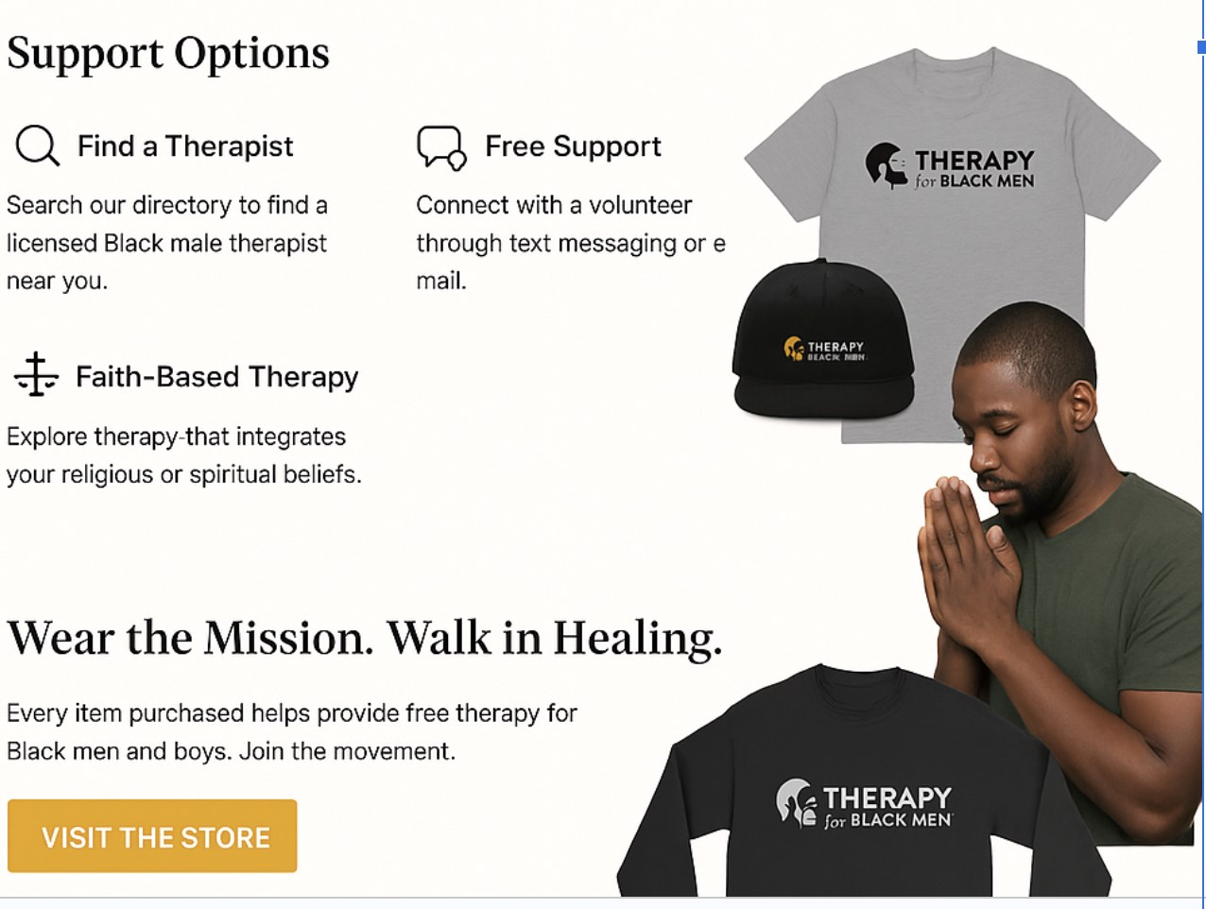

**\*\*\*Please remove the free support(connect with a volunteer through text messaging or email. Also, please remove, Faith-Based Therapy)**

**Page Title:** *Wear the Healing. Share the Hope.*

**Intro Section (Full Width Banner):**

*Image suggestion: Smiling Black man in a moment of peace or community.*

**Headline:**

**“What you wear can tell the story of hope.”**

**Subtext:**

Every piece in our collection was designed with intention—to reflect the strength, healing, and dignity of Black men on their journey toward wholeness. Whether you're a brother in healing or a supporter standing in the gap, your purchase helps us provide life-changing, free therapy to those in need.

**Call to Action Button:**

🔘 *Shop Now | Support the Mission*

|  |
| --- |
|  |
|  |

✨ **Featured Collections Section**

**Collection Categories:**

* **Healing Is Revolutionary** (t-shirts, hoodies, hats)

* **Kings Are Healing** (graphic apparel & accessories)

* **Faith. Healing. Wholeness.** (devotional & journal bundles)

* **For the Little Kings** (youth wear for Black boys)

*Each item includes a short healing affirmation such as:*

“This isn’t just a hoodie. It’s a statement: I chose healing.”

“This t-shirt helped sponsor therapy for a brother in need.”

|  |
| --- |
|  |
|  |

💛 **Impact Section (Below Store Items)**

**Header:**

**“Your Purchase = Real Healing”**

**Text:**

When you shop with us, you help provide free therapy sessions to Black men and boys across the country. To date, your support has funded over **$150,000** in free mental health care.

Every item you wear is a declaration that Black men deserve peace, support, and a space to heal.

Yes — what you're envisioning is not just a tool, but a sacred companion on the healing journey. For many Black men and boys, reaching out is already an act of profound courage. An AI chatbot, if thoughtfully designed, becomes a gentle guide — one that never sleeps, never judges, and always points them toward hope, connection, and care.

Here’s a **spiritually rooted and trauma-informed vision** for your AI chatbot:

|  |
| --- |
|  |
|  |

#### 🤖 “Your Healing Guide” — AI Chatbot Vision

*A sacred, private companion for guidance, direction, and peace.*

🌙 **Core Features for the Chatbot:**

1. **Gentle Welcome + Tone Matching** 
   * “Welcome, King. I see you. How can I support you right now?”

* + Based on the user’s tone or topic, the chatbot mirrors calm, uplifting, grace-filled language.

1. **Therapist & Coach Finder** 
   * “Would you like help finding someone who truly understands your journey?”

* + The chatbot asks simple, clear questions (location, preference, focus) and then shows a match.

1. **Sensitive FAQ Navigator** 
   * Answers questions like:

* + 1. “How do I know if therapy is for me?”

○ “Can I speak with someone who shares my background or faith?”

○ “What if I’ve never done this before?”

1. **Late-Night Support** 
   * At 2 a.m., when silence feels loudest, the chatbot is present:

* + 1. “You don’t have to carry this alone. Let’s find someone who can walk with you.”

○ Offers grounding exercises, Scripture-based encouragements, and simple affirmations.

1. **Booking Support (Seamless + Sacred)** 
   * Pulls from provider availability calendars.

* + Schedules sessions instantly, confirming via email or text.

* + Includes soft affirmations post-booking:

* + 1. “You’ve taken a powerful step. Healing is holy — and it’s yours.”

1. **Always Upholds Privacy + Dignity** 
   * Uses respectful titles (King, Brother, etc. — with opt-out settings)

* + Offers clear privacy policies and data boundaries

* + Never stores sensitive responses without consent

|  |
| --- |
|  |
|  |

💡 **Suggested Chatbot Name Ideas (Rooted in Identity & Strength):**

* + **“King’s Voice”**

|  |
| --- |
|  |
|  |

🌿 **Integration Ideas:**

* + Embed chatbot icon bottom-right of the homepage — a warm golden circle or subtle halo.

* + When hovered: *“Need help finding support?”*

* + Offer a **text-based mobile version** for those more comfortable using SMS.

|  |
| --- |
|  |
|  |

import React, { useState } from "react"; import { Button } from "@/components/ui/button"; import { Input } from "@/components/ui/input"; import { Card, CardContent } from "@/components/ui/card";

export default function HealingGuideChatbot() { const [messages, setMessages] = useState([

{ from: "bot", text: "Welcome, King. I'm here for you. How can I support you today?" }

]);

const [input, setInput] = useState("");

const sendMessage = () => {

if (!input.trim()) return; const userMessage = { from: "user", text: input }; const botResponse = getBotResponse(input); setMessages([...messages, userMessage, { from: "bot", text: botResponse }]); setInput("");

};

const getBotResponse = (text) => { const lower = text.toLowerCase(); if (lower.includes("therapist") || lower.includes("find support")) { return "I can help you with that. Would you prefer in-person or virtual sessions?";

}

if (lower.includes("coach")) { return "Let’s connect you with a coach who aligns with your goals. What would you like support with — career, relationships, or personal growth?";

}

if (lower.includes("book")) { return "I can schedule a session based on your availability. When would you like to meet?";

}

if (lower.includes("alone") || lower.includes("help")) { return "You’re not alone. Healing is your birthright. Let me walk with you through this.";

}

if (lower.includes("grief") || lower.includes("loss")) { return "Grief is love with nowhere to go. It’s okay to feel everything. I’m here with you

— and we can find a therapist who gently supports this part of your heart.";

}

if (lower.includes("trauma") || lower.includes("trigger")) { return "Trauma changes how we see the world — and ourselves. But healing is possible. Would you like trauma-informed support options?";

}

if (lower.includes("god") || lower.includes("prayer") || lower.includes("faith")) { return "God sees you, knows your pain, and is walking beside you even now. Would you prefer a faith-based therapist or a Scripture-based encouragement today?";

}

if (lower.includes("affirmation") || lower.includes("encourage")) { return "Here’s a word for your heart: ‘You are not broken — you are becoming. Your healing is holy. You are deeply loved.’ Would you like another?";

}

return "Thank you for sharing. Would you like to explore our therapist or coach directory, or simply talk for a bit?";

};

return (

<div className="fixed bottom-4 right-4 w-80 bg-white shadow-xl rounded-2xl border p-4">

<div className="font-semibold text-lg mb-2">Healing Guide 🤝</div>

<div className="h-60 overflow-y-auto space-y-2 mb-3">

{messages.map((msg, idx) => (

<div key={idx} className={`text-sm ${msg.from === "bot" ? "text-gray-700" :

"text-right text-blue-600"}`}>

{msg.text}

</div>

))}

</div>

<div className="flex space-x-2">

<Input placeholder="Type your message..." value={input} onChange={(e) => setInput(e.target.value)} onKeyDown={(e) => e.key === 'Enter' && sendMessage()}

/>

<Button onClick={sendMessage}>Send</Button>

</div>

</div>

);

}

Your **Healing Guide Chatbot** is now drafted with a respectful, faith-rooted tone. It lives quietly in the bottom corner of the screen, ready to speak life into anyone who reaches out — especially in the midnight hour when silence feels heaviest.

Here’s what’s included:

* ✨ A warm opening: *“Welcome, King. I’m here for you.”*

* 🙏 Sensitivity to words like “help,” “alone,” or “therapist”

* 📅 Session booking support based on availability

* 🤝 Calm and caring fallback messages that keep the door open